- Vulnerability of viewing ZABBIX account passwords arbitrarily in grafana login state or unauthorized access stateVulnerability details
When user is logged in and user is allowed to register, right click to view source code, Ctrl+F to search for password and api_jsonrpc. php get ZABBIX account password and URL address
2、Exploit proof
Case 2：
http://222.209.84.37:3000/login?redirect=%2F
Grafana v4.1.2 (commit: v4.1.2)

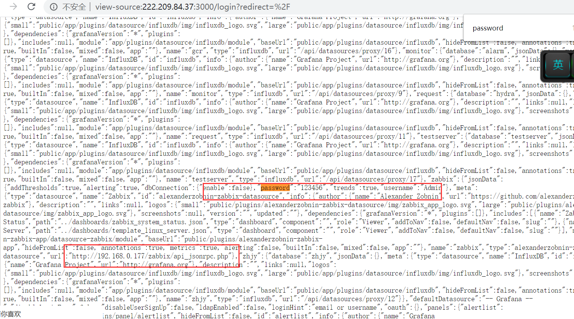
Case 3：
http://42.101.12.205:3000/login
Grafana v5.1.3
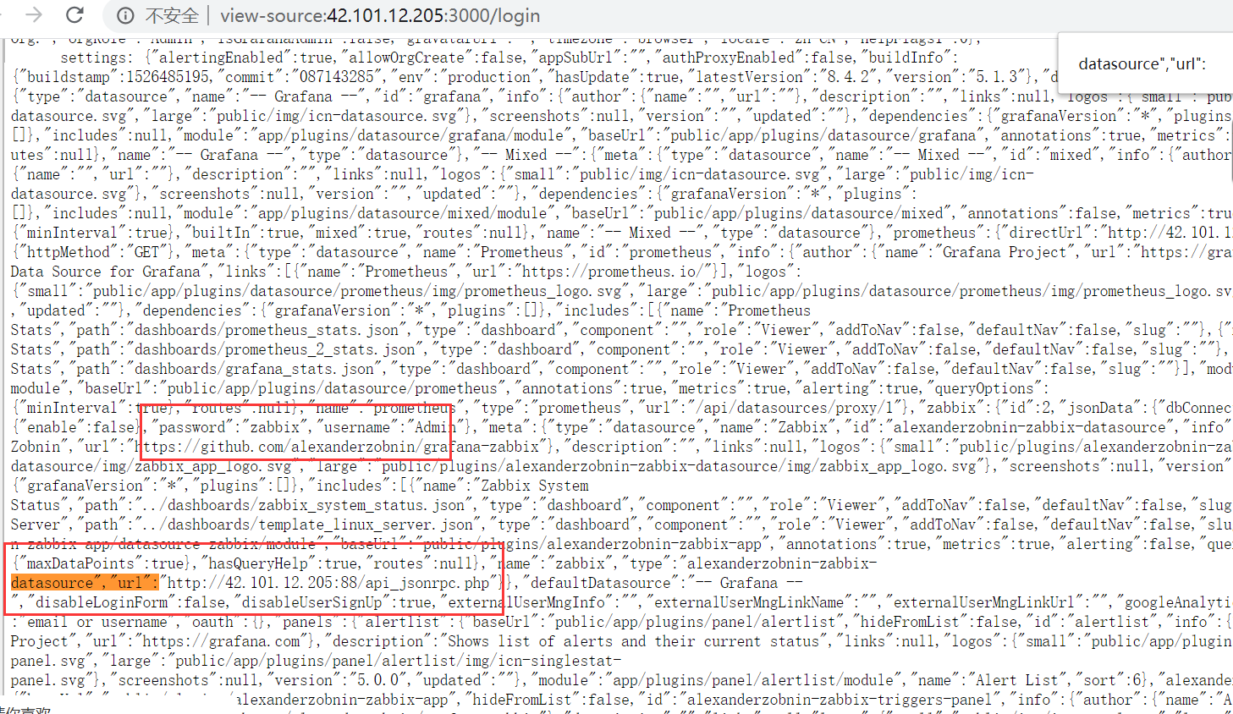

Case 4：
http://42.192.181.95:3000
Grafana v4.1.2
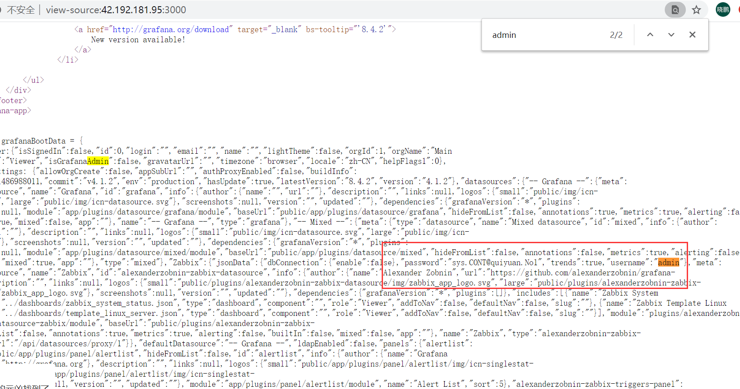

Case 5：
http://59.53.86.104:3000/
Grafana v6.6.2
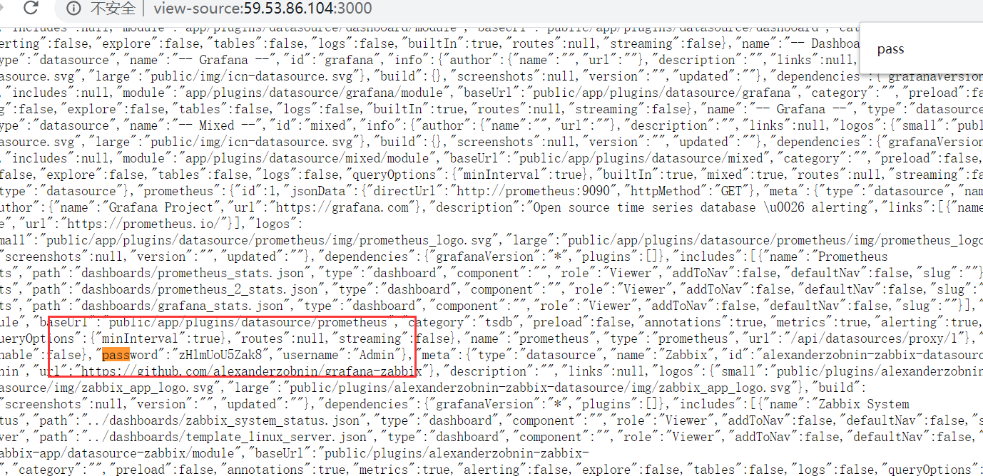

Case 6：
http://202.162.192.238:3000/
Grafana v6.2.3
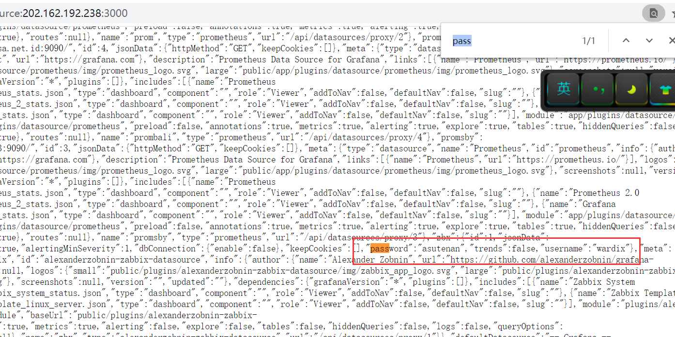

Case 7：
http://151.80.240.71:3000/?orgId=1
Grafana v7.3.4
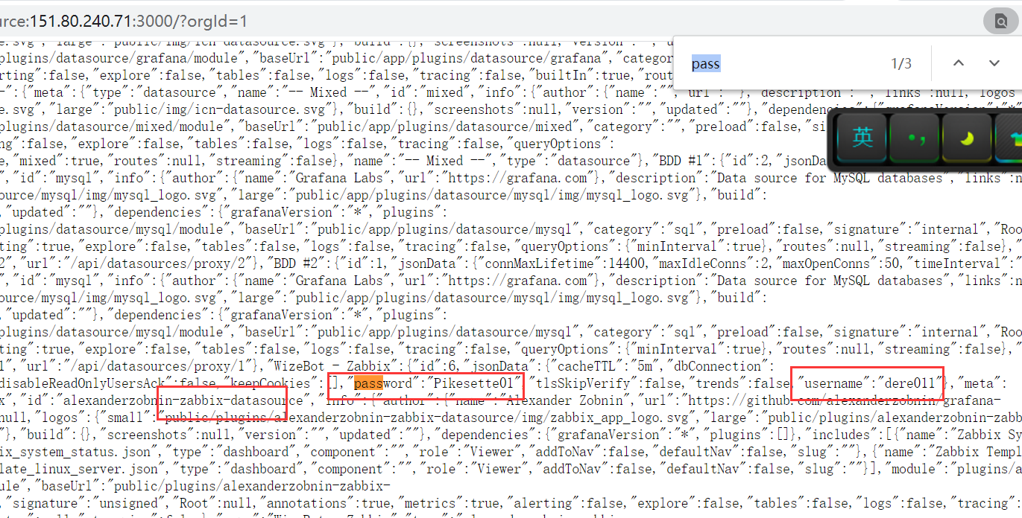
- Vulnerability hazard
It may lead to leak of URL address of ZABBIX account password, thus using ZABBIX vulnerability bash bounce shell

